Model of “Engineering forces” for training of engineers
O.I. Rebrinª, N.N. Gugis^{b}, S.A. Kamenskij^{b}, I.I. Sholinaª, A.S. Zhilinª
a) Ural Federal University named after the first Russian President B.N. Yeltsin,
Russia, 620002, Ekaterinburg, street Mira, 19
b) Ltd. Corporation of ferrous metal producers, Russia, 117630, Moscow, Street Starokaluzhskojie shosse, 62
*iisholina@gmail.com (corresponding author)
Keywords: engineering education, educational program, life cycle, training, lifelong learning, competence, practice
Abstract. The article presents models of effective interaction between academic institutions and industrial enterprises in the training of engineers. The project "engineering forces" is aimed at the formation of a system of training of elite engineering employees. The advantages of the network format of training are described, and it is shown that proposed approach allows using the best resources of various universities and enterprises of the industry for training of actual competences.
Introduction
In the context of the digital transformation of the economy, the educational community faces great challenges, which can be answered only in the partnership of academic institutions and industrial partners [1-4]. Solving common problems related to the content and technology of training, developing effective organizational models of training in the paradigm Life Long Learning specific enterprises and universities gain a lot of interesting experience, which is actively discussed and implemented in engineering practice [5-8].
The main directions of interaction between educational organizations, government and business are implemented in the framework of the creation of centers of continuous professional education (Fig. 1).
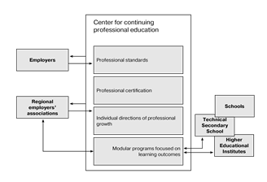
Fig. 1. Model of professional continuing education center.

The center of continuing professional education is created by building contractual relations between educational organizations of various levels, training centers or corporate universities in order to train personnel for a large industrial enterprise or a group of enterprises with the participation of the state authorities.
The transition of Russian higher education to a level system of training has caused the problem of adequate replacement of graduates of the specialty in most educational areas in the field of engineering, technology and technical Sciences. Attempts to bring the training of bachelors to the level of the former specialty without significant changes in the entire educational process are not successful. The development of engineering master's programs has not yet received a wide and meaningful distribution. In most cases, academic-type programs of a research nature are implemented at the master's level. It is necessary to pay attention to the fact that in contrast to the specialty undergraduates already have higher education and, as a rule, work, and not necessarily in the profession. This circumstance affects the motivation for learning and, accordingly, its result.
In General, the situation is a fair criticism on the part of employers in terms of the quality of training of graduates. This fully applies to the metallurgical industry, in the interests of which a significant number of budget places are allocated for training in bachelor's and master's degrees, but the quality output is extremely small.
Results and discussions
The problem statement is to develop and implement educational programs of elite training for the metallurgical industry. Elite training involves the production of a limited number of motivated and in-demand specialists in the field of metallurgical production.
To solve the problem of equivalent replacement of the best graduates of the specialty, it is proposed a development and implementation of an integrated network program "applied bachelor's degree – engineering master's degree". The program involves the restructuring of the training system for the 3rd and 4th year of bachelor's degree and the creation of new engineering master's programs. The restructuring of undergraduate programs can be of different nature: from a significant intensification of the educational process in order to prepare a graduate, comparable in competence with a graduate of the specialty, to a less profiled, combining the breadth and depth of training in the bachelor's degree with fine-tuning to the requirements of production in the engineering master's degree.
The programs will be created on a single methodological basis, including the formulation of learning outcomes, the choice of modern active educational technologies (project learning, e-learning environment, etc.), an independent assessment of the achievement of the stated results. At all stages of the creation and implementation of programs, a significant role is assigned to the interested participation of specialists of industrial partners.
As an option, the selection for training in elite programs can be held among students who have completed two years of study in the bachelor's degree. Selection criteria-successful development of the fundamental part of the educational program and motivation to work in the industry.
A number of leading universities of the country with the necessary base and competence in training in the field of metallurgy and having effective partnerships with large metallurgical enterprises will participate in the development and implementation of elite programs. To work on the programs, a creative team will be made, including the best teachers of the University and specialists of industrial enterprises.
Each of the project participants develops and implements a certain set of agreed program modules. The network form of implementation of such programs involves the mobility of both students who master certain parts of the programs and the necessary practice in various universities and enterprises, and teachers who can teach students at other universities. At the first stage of the project implementation, the recruitment for the elite undergraduate program (budget places) at each University can be from 10 to 15 people. The total number of students at the three partner universities is from 30 to 45 people. Admission to the integrated master's program also involves competitive selection with the release of the first 15-30 metallurgical engineers. The scale of the project in the future can be increased to the size of the needs of industrial partners in the graduates of elite programs. In the process of training, industrial enterprises can conclude contracts with students on targeted training, which will make certainty in the future career path of students. Graduates of the programs will receive in addition to the diploma of their University a joint diploma of universities and enterprises of the project participants.
In the context of the digital economy, there are new challenges for universities and partner enterprises to develop human resources that can ensure the competitiveness of enterprises. Combining efforts and resources for the training of engineers is becoming a common practice, while the relevance of the development of new approaches to the formation of the content of training for the long-term development of industries comes to the first place.
The distinctive features of the model that ensure the effectiveness of achieving learning outcomes and the required quality of training are, first of all, network forms that allow attracting the best resources of educational centers for the implementation of training and ensuring the mobility of students. The optimal balance of classical forms of training and various modern trainings is aimed at the formation of not only the basic professional competencies, but also personal and interpersonal qualities, such as the ability to solve problems, to work effectively in a team, to think creatively. The modular principle of educational programs provides adaptability to changing industrial technologies and makes it possible to form individual educational trajectories.
Described above approaches to the design of “engineering forces” programs were refined during the approbation process to the level of functional model (fig. 2) and model of quality assurance (fig. 3). The functional model based on the development cycle of the program provides a constant updating the content and technologies of training.
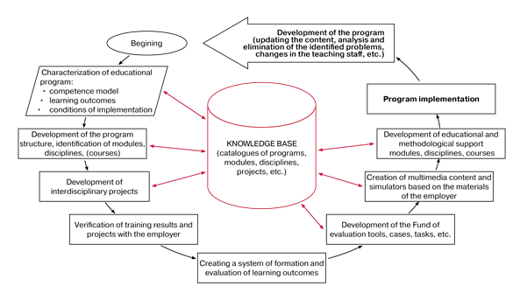
Fig. 2. Functional model of educational programs.

The basis of ensuring the quality (fig. 3) of graduates training is in a monitoring system of learning outcomes at different stages: from design to presentation of final thesis.
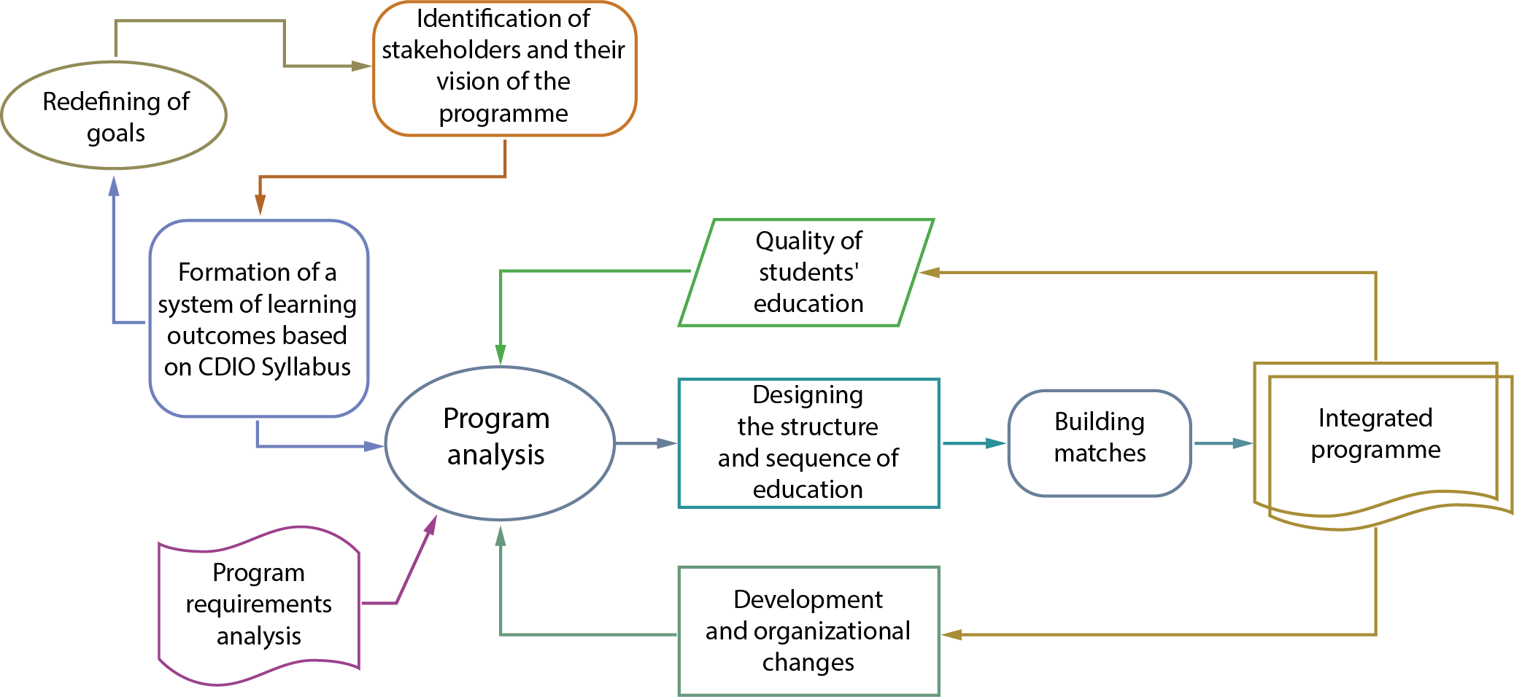
Fig. 3. Quality assurance model.

In General, the presented developments are of great practical importance for the effective staffing of the metallurgical industry. Partnership, integration of efforts of employers and educational organizations are key factors to ensure the quality of training, adequate to the needs of the economy and the challenges of our time. The variable model, which is based on the modular principle of construction, provides the required flexibility in the construction of individual directions and inclusion in engineering contexts, which provides professional development and horizontal and vertical mobility of personnel.

Acknowledgement. The article is prepared in the framework of the project" Comparative analysis of social effects and the impact of institutional conditions on the training of specialists in engineering areas", implemented with the support of the Russian Foundation for Basic Research - RFBR (grant № 19-011-00252).
References
- Kamp A. Impact of global forces and empowering situations on engineering education in 2030 / A. Kamp, R. Klassen // Proceedings of the 12th International CDIO Conference. – Turku : Turku University of Applied Sciences, 2016. – P. 1110-1120. Features of the modern educational environment for engineers / O. Rebrin, I. Sholina. // DAAAM International Scientific Book 2014. – 2014. – P 501-508.
- Crawley E. F. Rethinking Engineering Education: The CDIO Approach / E. F. Crawley, J. Malmqvist, S. Östlund ; Springer. – 2014. – 311 p. – ISBN-13:978-0387382876.
- OECD Science, Technology and Industry Scoreboard 2015: Innovation for growth and society [Electronic resource] / OECD Publishing. – Paris, 2015. – 264 p. – Mode of access:http://dx.doi.org/10.1787/sti_scoreboard-2015-en.
- A Tuning-AHELO Conceptual Framework of Expected Desired/Learning Outcomes in Engineering [Electronic resource] / OECD Publishing. – Paris, 2011. – 55 p. – Mode of access:http://dx.doi.org/10.1787/5kghtchn8mbn-en.
- 42 p. – Mode of access: http://publications.lib.chalmers.se/records/fulltext/local_143186.pdf.
- Rebrin O. I. Interdisciplinary Project for Bachelor Engineering Program [Electronic resource] / O. I. Rebrin, I. I. Sholina, S.A. Berestova // Proceedings of the 10th International CDIO Conference / Universitat Politechnica de Catalunya. – Barcelona, 2014. – Mode of access: http://www.cdio.org/node/6072. Rebrin O. I. Interdisciplinary Project for Bachelor Engineering Program [Electronic resource] / O. I. Rebrin, I. I. Sholina, S.A. Berestova // Proceedings of the 10th International CDIO Conference / Universitat Politechnica de Catalunya. – Barcelona, 2014. – Mode of access: http://www.cdio.org/node/6072.
- Rebrin O.I., Sholina I.I. (2011). [“TEMPUS” – The way in the European higher education]. Vestnik Tverskogo gosudarstvennogo universiteta. Seriya: Pedagogika i psihologiya =Letters of Tverskoij State University. Series: Pedagogics and Psychology. No. 4, pp. 152-160. (In Russ., abstract in Eng.)

